ST. ERVAN PARISH COUNCIL
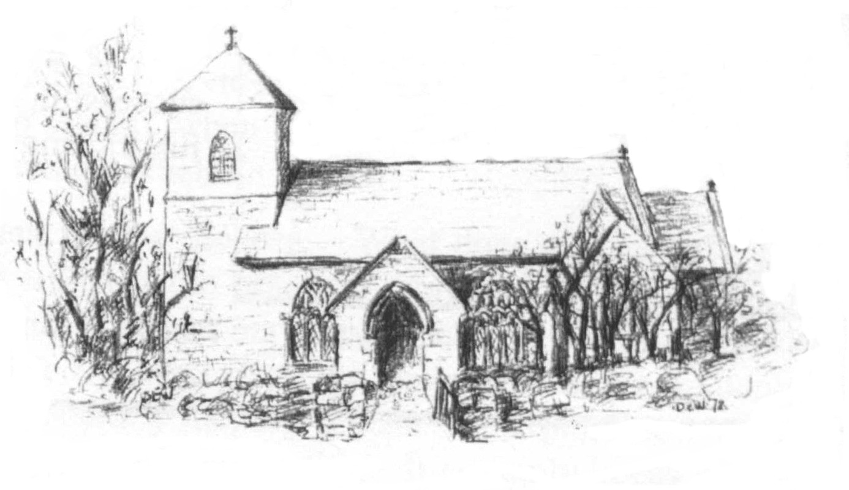
Jacqui Peskett
Parish Clerk
Tel 07835 937261
Email stervanpc@outlook.com

St Ervan Parish Council Meeting Minutes – Tuesday 7th May 2024 held at St Ervan Village Hall commencing at 7.30 pm.

Present: Cllrs R Biddick (Chair), J Skinner, K Wood, L Clarke,

Public Participation:
Amanda Pennington representing Wildanet gave a short presentation on the works being undertaken in rural areas for full fibre Internet connection. A Government backed scheme to give better Iternet speeds and quality. There was an opportunity for questions to be asked.

1/24. Apologies and Announcements: Cllrs M Biddick, Kent & Eustace. Cornwall Councillor Stephen Rushworth.

2/24. Declarations of interest:
To RECEIVE any Declaration of Interest from Members, to RESOLVE to grant any requests for Dispensation in line with the Councilor Code of Conduct 2021 if appropriate. None.

3/24. Election of Chairman:
To receive the Chairman’s Declaration of Acceptance of Office or, if the Chairman is not present, to resolve that such a Declaration be made at or before, the next Ordinary Meeting of the Council.
It was proposed Cllr Skinner seconded by Cllr Wood and resolved that Cllr R Biddick be re elected as Chairman – all in favour – carried. Declaration of Acceptance signed and witnessed by the Clerk.

4/24. Election of Vice Chair:
To receive the Chairman’s Declaration of Acceptance of Office or if not present, to resolve that such a Declaration be made at or before, the next Ordinary Meeting of the Council.
It was proposed Cllr Biddick seconded by Cllr Clarke and resolved that Cllr J Skinner be re elected as Vice Chairman – all in favour – carried. Declaration of Acceptance signed and witnessed by the Clerk.

5/24. St Ervan Parish Council Meeting 5th March 2024
To RESOLVE to adopt the minutes of the meeting held on the above date and having previously been circulated, to be signed. It was proposed Cllr Wood seconded by Cllr Clarke and resolved that these reflect a true record of the that meeting. All in favour – carried.

6/24. Matters arising and Correspondence:
- To RECEIVE the Police report (previously circulated)

7/24. Planning Applications: to CONSIDER Planning Applications or any that may be received since the agenda was published:
Demolition of former piggeries to 3 live work units
Planning Application
Old St Merryn Aerodrome The Old Airfield St Merryn Padstow Cornwall PL28 8PT
Ref. No: PA24/02679 | Received: Tue 02 Apr 2024 | Validated: Tue 30 Apr 2024 | Status: Pending
After discussion, Members voted to OBJECT to this application.

8/24. Items for Information:
- Update on CIL monies. The Clerk advised Members to consider projects to use remaining monies.
- Refurbishment of Telephone kiosk at Penrose which has the defibrillator in it. Needs repainting, glass replaced and a general tidy up. Members agreed that the Clerk should make contact with Dreckly magazine and others media to try and find volunteers to carry out the work. The Parish Council will supply paint etc.

9/24. Highways To CONSIDER any issues that may have arisen and RESOLVE appropriate action.
- White lines at Rumford Crossroads to be reported again (PL27 7RT).
- Pothole to be reported (PL27 7RU).
AUDIT 2024
10/24. To CONSIDER the Internal Audit for 2024. The Clerk advised the Internal Audit had been completed and there were no issues raised.

11/24. To APPROVE and sign the completed forms for the Financial Year ending 31st March 2024 and submit to the External Auditor:
- AGAR to receive and approve the Annual Governance Statement for submission to BDO LLP- signed by the Chairman & Clerk.

- AGAR to receive and approve the Annual Accounting Statement for submission to BDO LLP-signed by the Chairman & Clerk.

- AGAR to receive and approve the Certificate of Exemption for submission to BDO LLP- Signed by the Chairman & Clerk.

- AGAR to receive and approve the Conflict of Interests form for submission to BDO LLP- signed by the Chairman & Clerk.
12/24. Finance
Expenses
Clerk Renumeration ( 2 months) | £266.47
Clerks Expenses (2 months) | £51.25
HMRC/PAYE | £64.13
Carolyn May (Internal Audit) | £70.00
Income
Interest | £3.26
1st Precept payment | £2,100.00
Balances as at 26th April 2024
Treasurers Account | £36.96
Business Instant Access Account | £5,155.47
It was proposed Cllr Skinner seconded by Cllr wood and resolved that the above payments be made.

13/24. Items for July Meeting.
Donations.
The Chairman closed the meeting at 8.15pm.

Date Of Next Meeting Tuesday 2nd July 2024 @7.30pm

Signed………………………………………….

